**HBase**

HBase, as well as HDFS, are one of the essential components of the Hadoop ecosystem, which help in storing as well as processing huge datasets. HDFS and HBase can handle the data well, whether structured, semi-structured, or unstructured.

In Hadoop, HBase is the NoSQL database that runs on top of HDFS. HBase stores the data in a column-oriented form known as the Hadoop database. HBase provides consistent reads and writes in real-time and horizontal scalability.

### Components of HBase

* Hbase master
* Region Server
* Region
* Zookeeper

1. HMaster: It is the Master server in HBase architecture. It is the monitoring agent to monitor all Region Servers, and also it is the responsibility of HMaster to be the interface for all the metadata changes. It runs on NameNode.

2. Regions Servers: When Region Server receives, writes, and reads requests from the client, it assigns the request to a specific region where the actual column family resides. However, the client can directly contact Region servers; there is no need for HMaster’s mandatory permission to the client regarding communication with Region Servers. When client needs help with operations related to metadata and schema changes, they must request assistance from HMaster.

3. Regions: Regions are the essential building elements of the HBase cluster that consists of the distribution of tables and are comprised of Column families. It contains multiple stores, one for each column family. It consists of mainly two components, which are Memstore and Hfile.

4. ZooKeeper: In Hbase, Zookeeper is a centralized monitoring server that maintains configuration information and provides distributed synchronization. Distributed synchronization is to access the distributed applications running across the cluster to provide coordination services between nodes. If the client wants to communicate with regions, the server’s client has to approach ZooKeeper first.

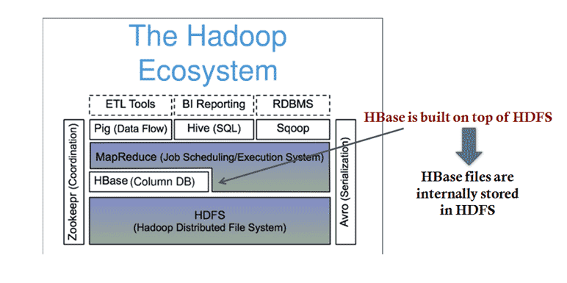**HBase Architecture:**

HBase is a part of Hadoop’s Ecosystem.

In-Depth Model:

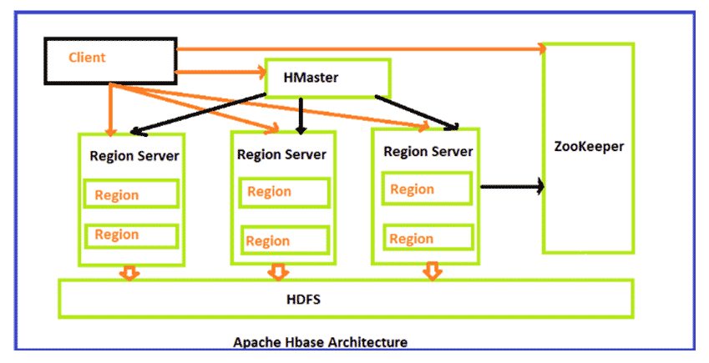

**Key Differences Between HDFS vs HBase**

Below is the difference between HDFS vs HBase:

1. HDFS stores large files well because it is a distributed file system. HBase, however, is built on top of HDFS and offers fast record lookups (and updates) for large tables.
2. HDFS has based on the GFS (Google File System) file system. But HBase is distributed – uses HDFS for storage, column – Oriented, Multi-Dimensional (Versions), and Storage System.
3. HDFS uses HIVE as one of its components for the quire language, which is HIVE Query Language (HQL), but Hbase is NOT a SQL Database which means:- No Joins, no query engine, no datatypes, no (damn) SQL, No Schema and no DBA needed.
4. As HDFS is a distributed storage unit hence has no specific language other than the commands used like the UNIX flavor like, for example: - Hadoop dfs -mkdir /foodir
5. hadoop dfs -cat /foodir/myfile.txt
6. hadoop dfs -rm /foodir/myfile.txt

But on the other hand, HBase has its interface in the form of HBase Shell, for example:

1. hbase(main):003:0> create ‘test’, ‘cf’

0 row(s) in 1.2200 seconds

1. hbase(main):004:0> put ‘test’, ‘row1’, ‘cf:a’, ‘value1’

0 row(s) in 0.0560 seconds

1. hbase(main):005:0> put ‘test’, ‘row2’, ‘cf:b’, ‘value2’

0 row(s) in 0.0370 seconds

1. hbase(main):006:0> put ‘test’, ‘row3’, ‘cf:c’, ‘value3’

0 row(s) in 0.0450 seconds

1. hbase(main):007:0> scan ‘test’

ROW COLUMN+CELL

row1 column=cf:a, timestamp=1288380727188, value=value1

row2 column=cf:b, timestamp=1288380738440, value=value2

row3 column=cf:c, timestamp=1288380747365, value=value3

3 row(s) in 0.0590 seconds

**HDFS vs HBase Comparision Table**

Following is the comparison table between HDFS vs HBase

|  |  |  |
| --- | --- | --- |
| **Basis for Comparison** | **HDFS** | **HBase** |
| **Why We Need Them** | Need to process huge datasets on large clusters of computers. | HBase is a distributed column-oriented data store built on top of HDFS. |
| **Nodes Fail Every Day** | Failure is expected rather than exceptional.  The number of nodes in a cluster is not constant. | HBase is an Apache open-source project that aims to provide storage for Hadoop Distributed Computing. |
| **Write Pattern** | Append Only | Random write, bulk incremental |
| **Read Pattern** | Full table scan, partition table scan | Random read, small range scan, or table scan |
| **W/R Pattern** | HDFS ideally suits use cases where data is written once and read repeatedly. | HBase is ideally suited for random writing and reading of data stored in HDFS. |
| **Hive(SQL) Performance** | Relatively very good. | 4-5 times slower. |
| **Structured Storage** | Do it yourself or TSV or Sequence File. | Sparse column family data model. |
| **Maximum Data Size** | Typically can store near about 30 PB. | Approximately around 1 PB. |
| **Dynamic Changes** | HDFS has a rigid architecture that does not allow changes. It doesn’t facilitate dynamic storage. | You can use HBase for standalone applications and make dynamic changes to it. |
| **Data Distribution** | Data is stored in a distributed manner across the nodes in a cluster. Data is divided into blocks and then held over nodes in the HDFS cluster. | Tables are distributed on the cluster via regions, and regions are automatically split and re-distributed as your data grows. |
| **Data Storage** | All the data is stored in the form of small files, and all files are of a typical size of 64 MB (which is 128 MB in the newer version) | The data is stored in tables, each consisting of rows and columns. |
| **Data Modeling** | In HDFS, we use the Map Reduce technique, which divides the files into Key-Value pairs. | HBase is based on Google’s Big Table model, which uses Key-Value pairs. |
| **Operations** | It has high-latency operations. | It has low-latency operations. |
| **Accessibility** | It is primarily accessed through MR (Map Reduce) jobs. | You can access it through shell commands or client APIs in Java, REST, Avro, or Thrift. |